**FIELDS:-**

Budget, original language, popularity, release date, revenue, runtime, status, vote_average, vote_count

original title, title

**Start Tableau:-**

1. Open Tableau.

2. On the left, Connect : To a File - Other - movies_metadata (dataset)

3. Drag the "movies_metadata.csv" sheet.

4. Click the "Worksheet" tab in the bottom left corner to start exploring your data.

**FIRST :- ORIGINAL TITLE - REVENUE**

1. Put "Original Title" in Rows

2. Put "Revenue" in "Text".

3. In "Show Me", select the "Treemaps" representation

4. Put SUM(Revenue) in colors.

5. select color as red-green diverging.

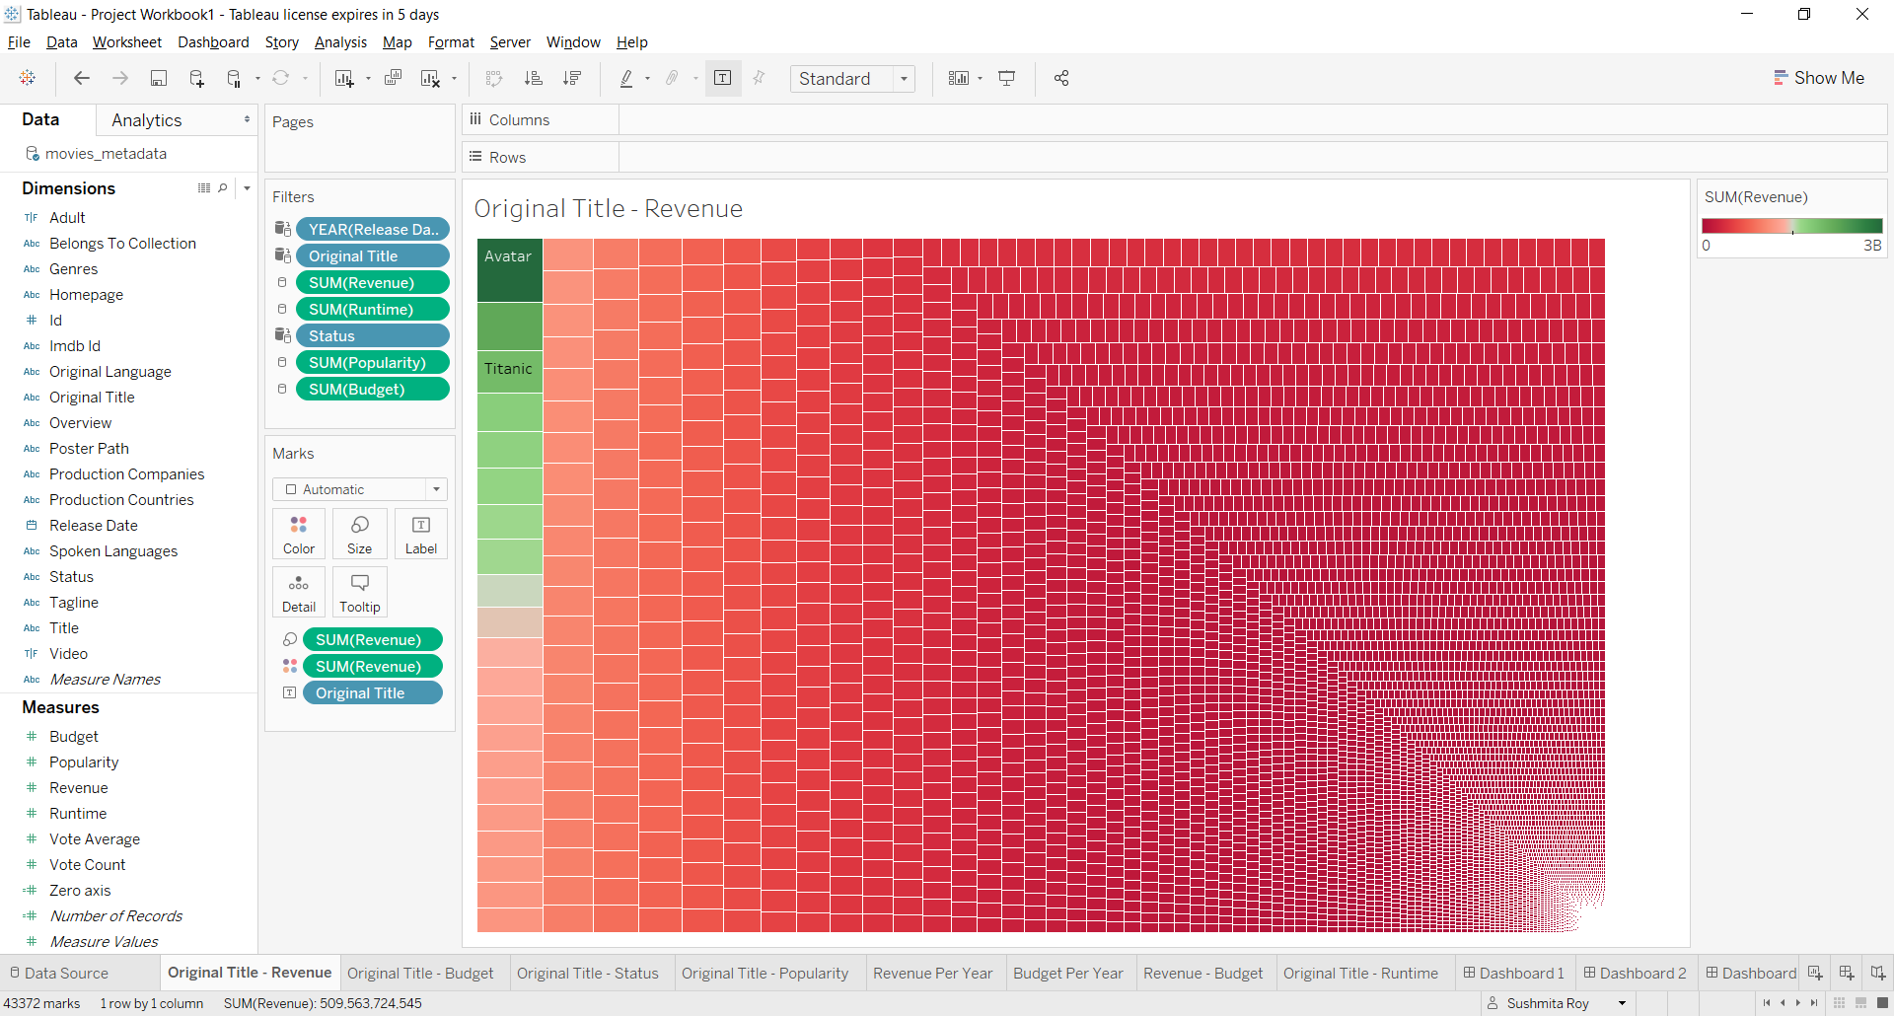

**SECOND :- ORIGINAL TITLE - BUDGET**

1. "Original Title" in Columns.

2. "Budget" in Text.

3. SUM(Budget) in Rows.

4. SUM(Budget) in color

5. edit color

6. Original Title - Sort - Field - Descending - Budget - Sum

7. Original Title - Show Filter - Use all, Top - By field - 50

8. Entire View

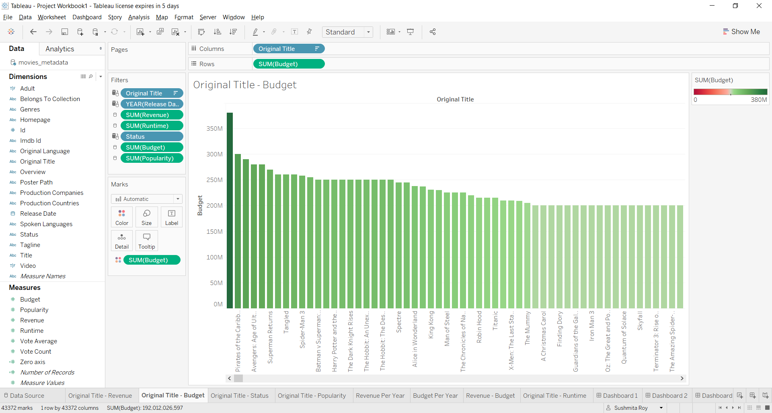

**THIRD :- ORIGINAL TITLE - STATUS**

1. Put "Number of Records" from Measures to Rows.

2. Again, put "Number of Records" from Measures to Rows.

3. For both -> Measure (Sum) - Minimum

4. Marks - All - Pie

5. Drag to change size.

6. For the first one - put Status in Color, put Status in Label, put Revenue in Label

7. For the second one - dual axis (first image gayab with its values in second graph now)

8. For the second one - minimize the size so that you get the donut

9. Select the middle portion - Color - white.

10. put revenue in label.

11. select any colored section - Tooltip - Remove the "Minimum...." line. It will not be shown in the tooltip.

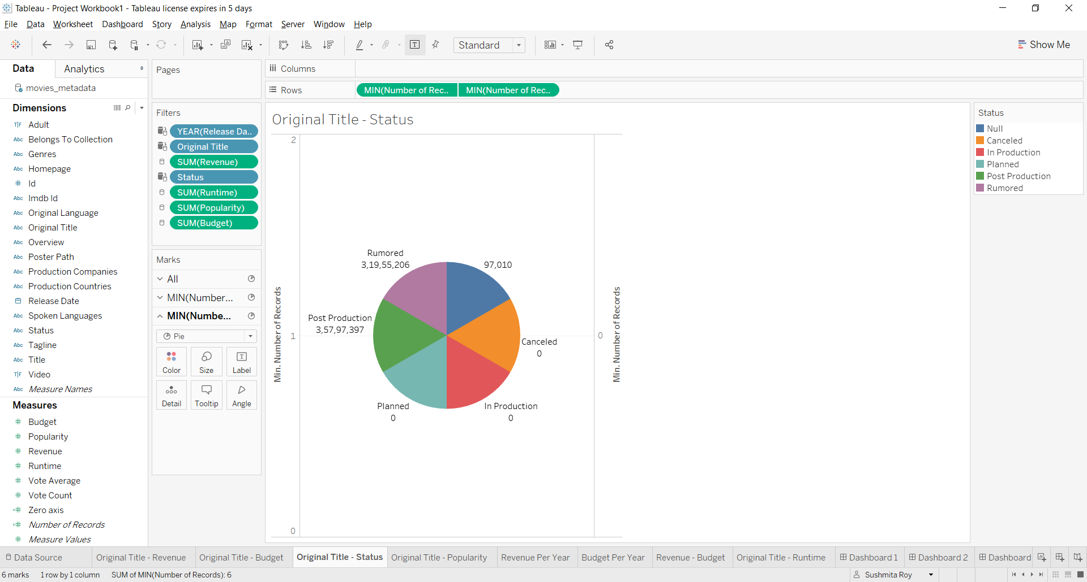

**FOURTH :- ORIGINAL TITLE - POPULARITY**

//Reference: https://www.youtube.com/watch?v=HnE4HgLcqyM

1. Drag Popularity in Text

2. Drag SUM(Popularity) in Column

3. Drag Released Date in Color

4. Drag Popularity in Size

5. Change the view to get vertical bars

6. In Mark, SUM(Population), right click "Quick Table Calculation". Then right click and select Compute Using -> "Release Date"

7. In Mark, right click on Label property and check - "Show mark labels" and select "Highlighted".

8. Change view type from "Standard" to "Entire View".

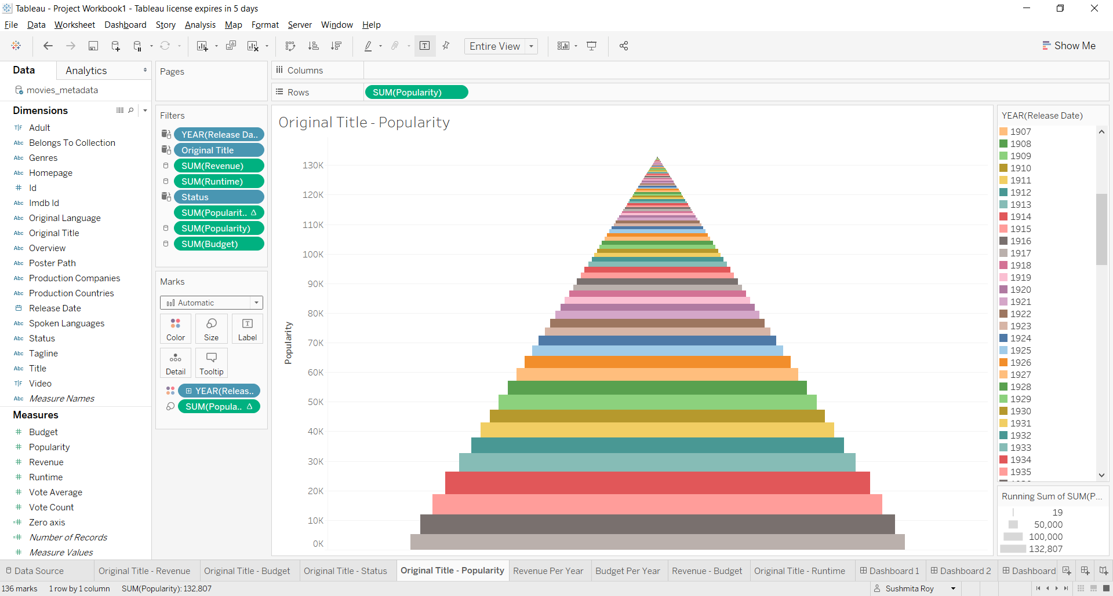

**FIFTH :- REVENUE PER YEAR**

"Release Date" in middle - goes to rows automatically

"Revenue" in Text - Displayed as SUM(Revenue)

Select graph

Sort - Field - Descending - Revenue - Sum

Year - Filter - Use all - Top 85

Entire View

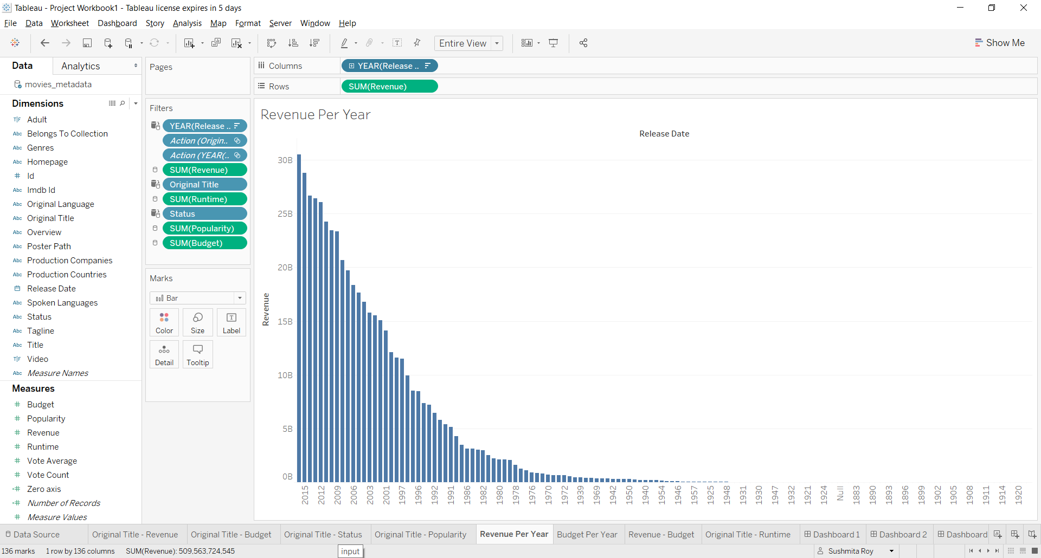

**SIXTH :- BUDGET PER YEAR**

"Release Date" in middle - goes to rows automatically. move it to columns

"Budget" in Text - Displayed as SUM(Budget). Put it in Rows.

Select "Packed Bubbles" graph type in "Show Me".

Click on "Color" and change it from blue to orange.

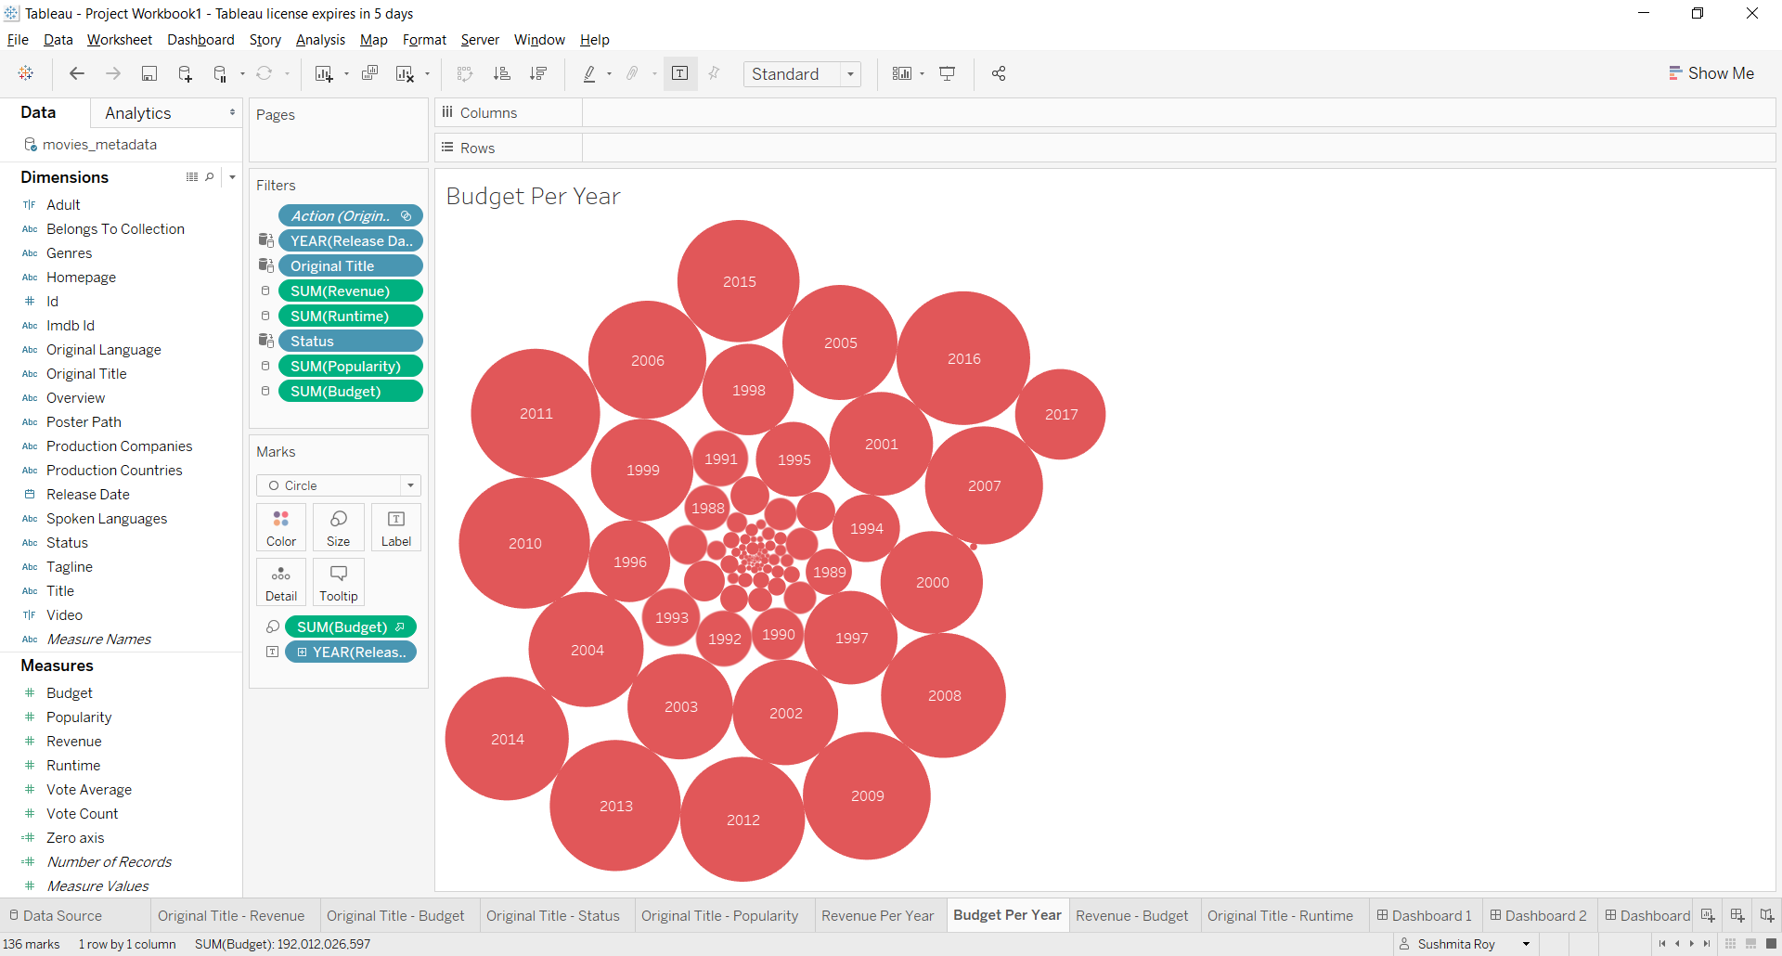

**SEVENTH :- REVENUE BUDGET RELATION**

//Reference: https://www.youtube.com/watch?v=LR_sNOGKfFU

1. Original Title in Rows

2. Put vote_average and vote_count in Columns

3. Right click on "Vote Average" axis and select "Edit Axis" - Scale : Reversed -> OK

4. Create Calculated Field - Name : Zero axis and Value : 0. Click on "OK". This field in now added in Measures.

5. Drag and drop this calculated field exactly in between "vote_average" and "vote_count" in Columns.

6. In SUM(Zero Axis) under Marks, Drag and drop "Original Title" in Text.

7. Go to "Original Title" in Rows and uncheck - Show Header.

8. Format - Lines

Sheet

Zero Lines - None

Axis Ticks - None

Columns

Grid Lines - None

9. In SUM(Zero Axis) under Marks, select "Text" in dropdown.

10. Hold Ctrl and drag SUM(Vote Average) from Columns and put it in Marks -> SUM(Vote Average) -> Color.

Hold Ctrl and drag SUM(Vote Count) from Columns and put it in Marks -> SUM(Vote Count) -> Color.

11. Vote_Count - Edit Color - Red Green Diverging

12. In Marks -> SUM(Vote Average) -> Label -> check "Show Mark Labels".

In Marks -> SUM(Vote Count) -> Label -> check "Show Mark Labels".

13. In Rows - Original Title. Filter Field - Descending - Vote Count - Sum.

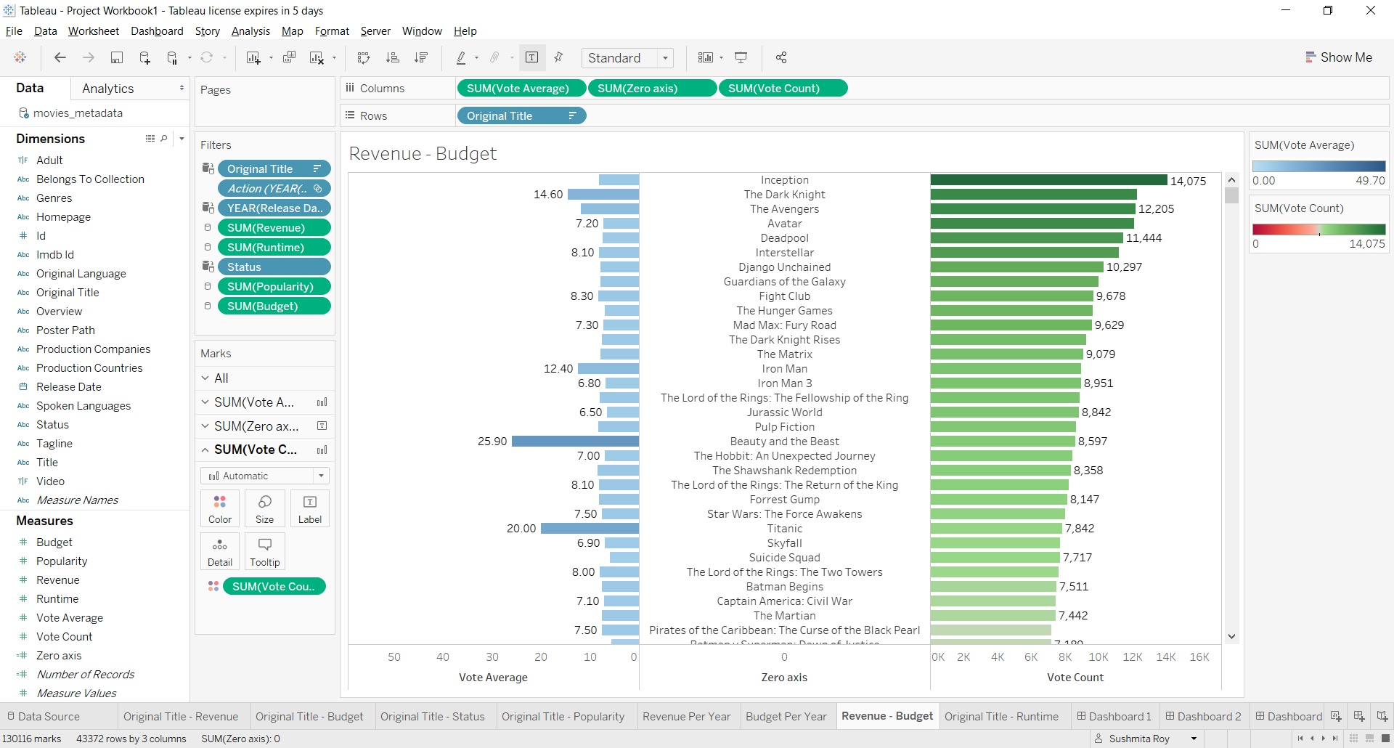

**EIGHTH :- ORIGINAL TITLE RUNTIME RELATION**

1. Original Title in Rows

2. Runtime in Columns

3. Ctrl and Runtime in Colors. Edit Colors and select Red-Green Diverging.

6. Original Title - Sort - Field - Descending - Runtime - Sum

7. Original Title - Show Filter - Use all, Top - By field - 100

8. Entire View

9. Swap Rows to Columns.

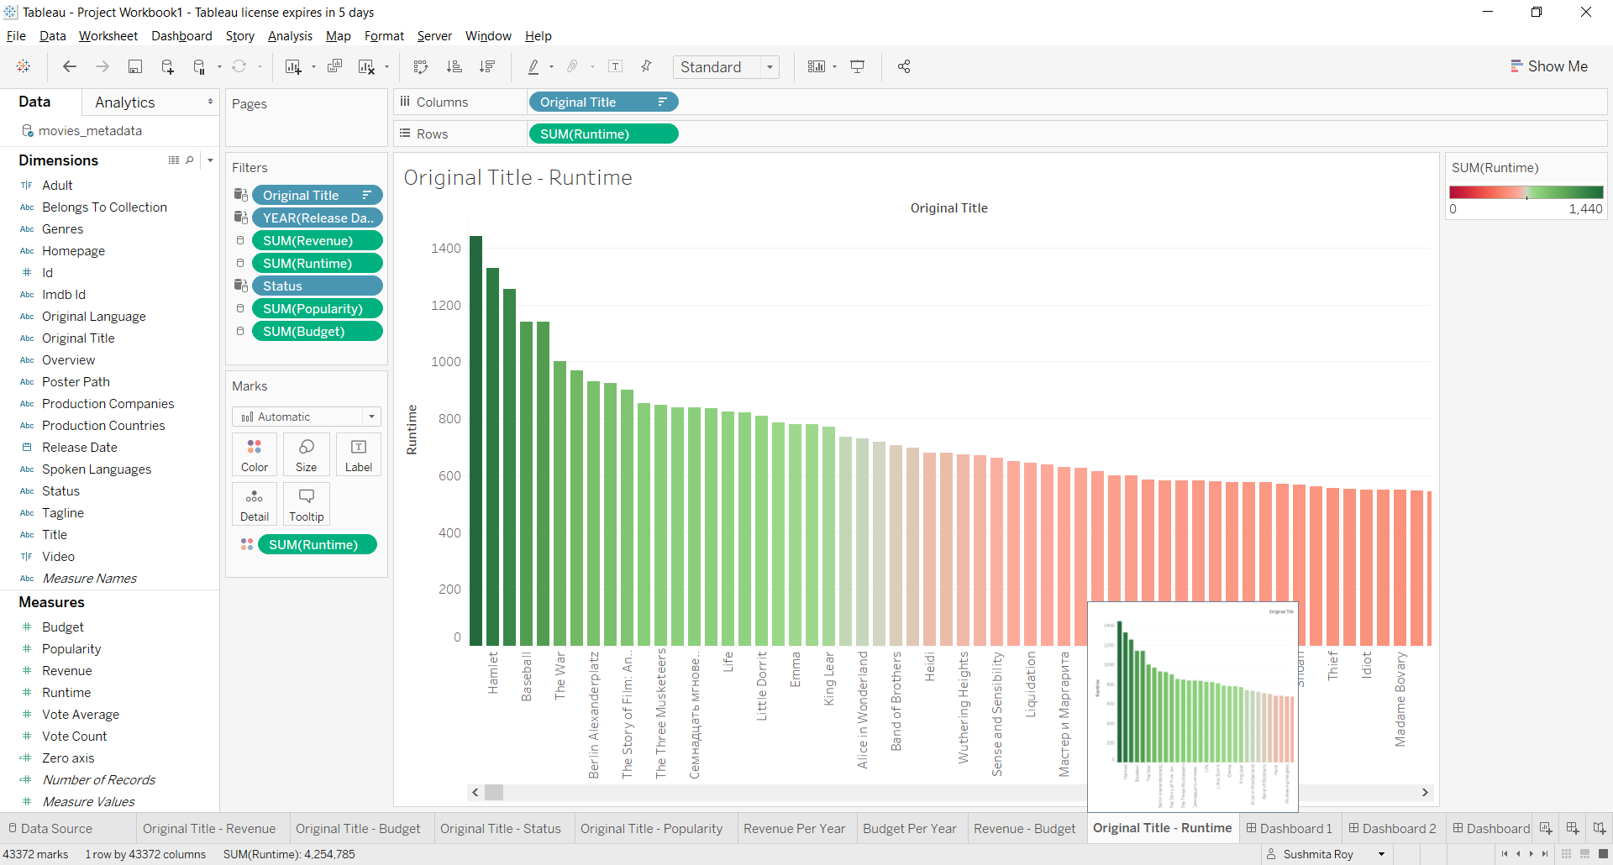

**BUILDING DASHBOARD:-**

Go to Dashboard -> New Dashboard

1. Device Size:- Generic Desktop

2. Tiled or floating - Select "Tiled". It automatically reaches the next available full space in smaller devices - Responsive.

Drag and Drop - "Revenue Budget" in the Dashboard space.

Delete the legend on the left.

Drag and Drop - "Budget Per Year" to the right of "Revenue Budget".

Drag and Drop - "Revenue per Year" bottom of "Budget Per Year".

CHANGE IN OTHER GRAPHS BASED ON CHANGES IN ONE GRAPH:-

In the "Profit by Category" graph, on the right click on "Use as filter". So changes in this graph will make changes in the other graphs too.

Do the "Use as filter" in all the graphs.

USE LIKE FILTERS ON GRAPHS CLICKS:- (Example Y-o-Y instead of full data)

In "Revenue Budget" - Filter - Original Title

In "Budget Per Year" - Filter - Year of Release Date

In "Revenue Per Year" - Filter - SUM of Revenue

ARRANGE IN ORDER YOU WANT:-

Since "Revenue" has less numbers, add it to the top.

Original Title - Multiple Values (list)

Right click in "Year of Release Date" and select "Single Value Slider".

Right click in all the filters and select "Apply to Worksheets" - "All Using Related Data Sources".

DASHBOARD TITLE:-

Drag Text from the Object in left and place it at the top. Give title to your dashboard. Resize it as per the size and height of text.

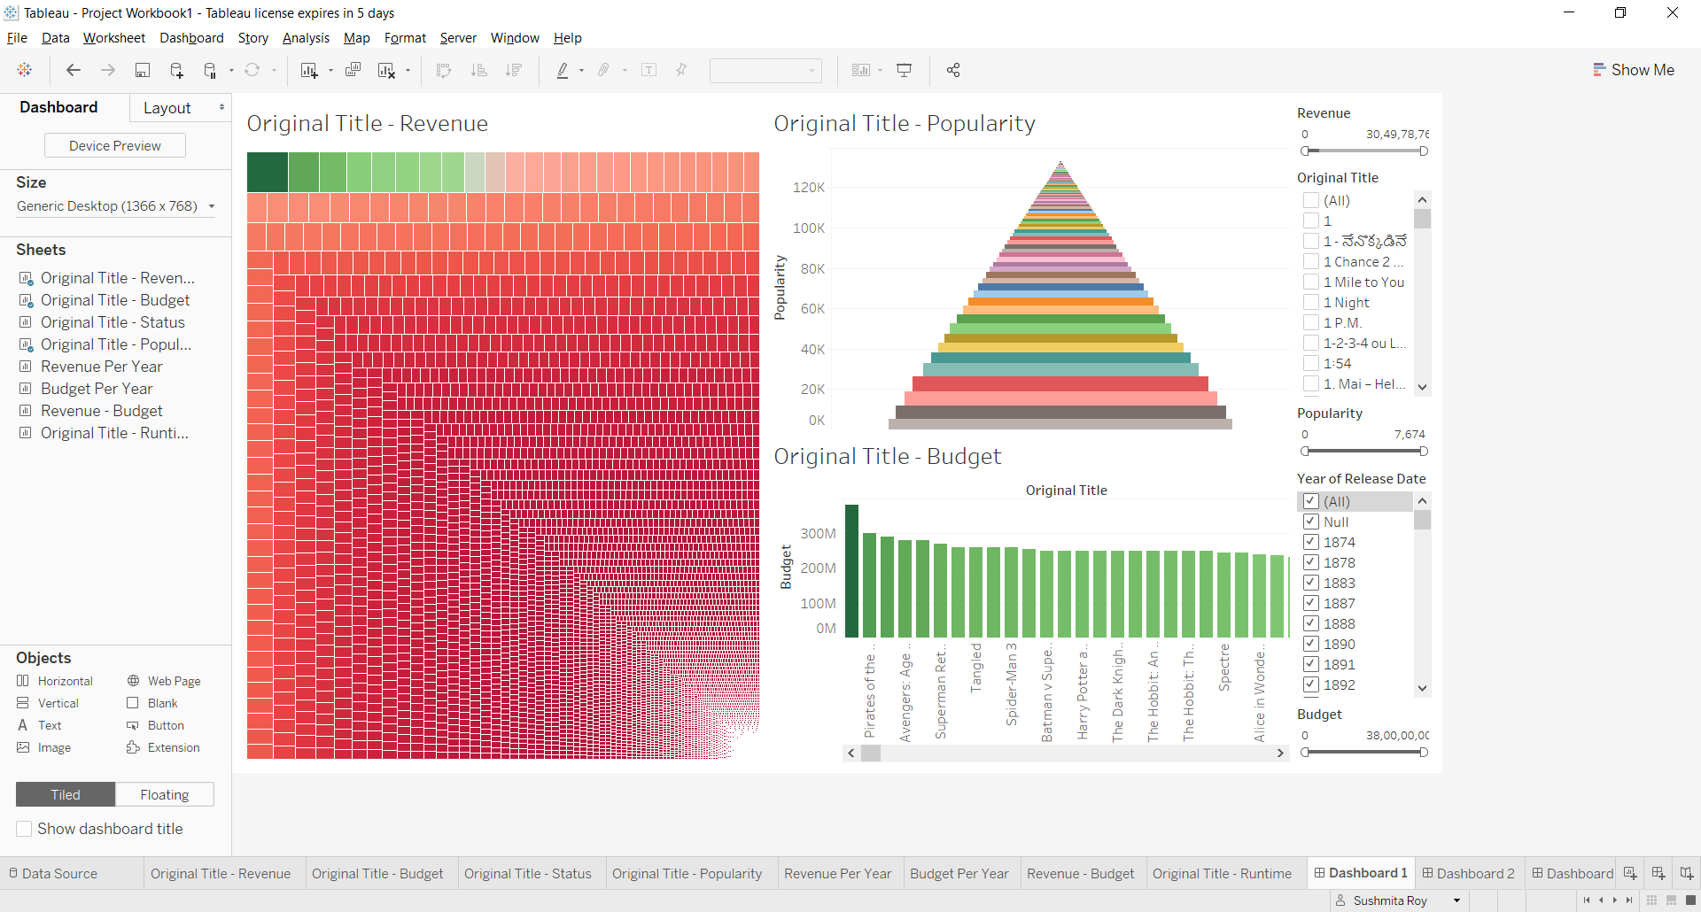

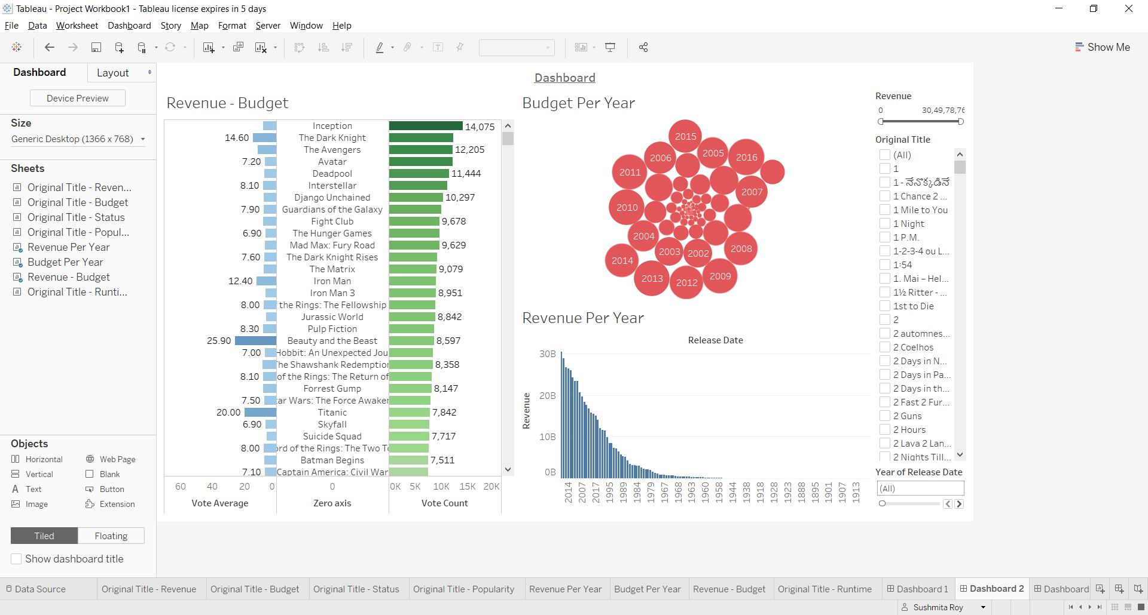

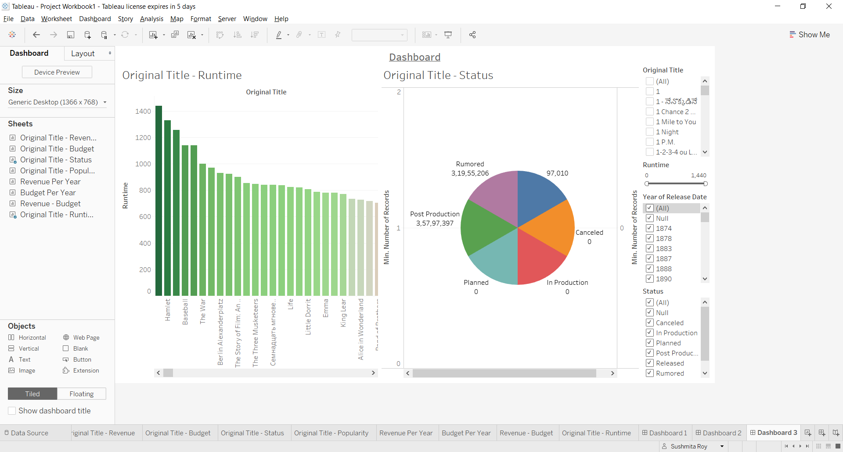

**Publish live Tableau dashboard on a web page:-**

Go to public.tableau.com

Login to this account

Open Tableau - Open your workbook. Go to Server - Tableau Public - Save to Tableau Public As -> Give name with which it will be saved on Tableau Public.

Click on "Edit Details" at the bottom

Click "Share" at the bottom. Copy the "Embed Code" part.

In HTML page, paste this:-

<!DOCTYPE html>

<html>

<head>

<title>Tableau Dashboard Demo</title>

</head>

<body>

This is my Tableau Dashboard..

//Embedded code goes here

</body>

</html>